TrashTracer AI: Revolutionising Urban Waste Management

A PROJECT REPORT

Submitted by
Manvi Tiwari ( 24BCE11398)
Rohan Rathi (24BCE10063)
Rishi Gupta (24BCE10641)
Yug Sanjay Kumar Shah (24BCE10719)
Ashutosh Shrivastava (24BCE11476)

in partial fulfillment for the award of the degree of

BACHELOR OF TECHNOLOGY
in
COMPUTER SCIENCE AND ENGINEERING



SCHOOL OF COMPUTING SCIENCE AND ENGINEERING

VIT BHOPAL UNIVERSITY

KOTHRIKALAN,SEHORE

MADHYA PRADESH - 466114

September 2025

BONAFIDE CERTIFICATE

Certified that this project report titled "TrashTracer AI: Revolutionising Urban Waste Management" is the bonafide work of MANVI TIWARI (24BCE11398), ROHAN RATHI (24BCE10063), RISHI GUPTA (24BCE10641), YUG SANJAY KUMAR SHAH (24BCE10719), and ASHUTOSH SHRIVASTAVA (24BCE11479) who carried out the project work under my supervision.Certified further that to the best of my knowledge the work reported at this time does not form part of any other project/research work based on which a degree or award was conferred on an earlier occasion on this or any other candidate.

PROGRAM CHAIR
Dr. Vikas Panthi
School of Computer Science and Engineering VIT BHOPAL UNIVERSITY

PROJECT GUIDE
DR JITENDRA P.S. MATHUR
School of Computer Science and Engineering VIT BHOPAL UNIVERSITY

ACKNOWLEDGEMENT

First and foremost, we would like to thank the Lord Almighty for His presence and immense blessings throughout the project work.

We wish to express our heartfelt gratitude to the Head of the Department, School of Computing Science and Engineering, for his valuable support and encouragement in carrying out this work.

We would like to thank our internal guide, Dr. Jitendra P.S. Mathur, for continually guiding and actively participating in our project, giving valuable suggestions to complete the project work.

We would like to thank all the technical and teaching staff of the School of Computing Science and Engineering, who extended directly or indirectly all support.

Last but not least, we are deeply indebted to our parents who have been the greatest support while we worked day and night for the project to make it a success.

LIST OF ABBREVIATIONS

1. AI: Artificial Intelligence
2. API: Application Programming Interface
3. CSS: Cascading Style Sheets
4. GPS: Global Positioning System
5. HTML: HyperText Markup Language
6. IoT: Internet of Things
7. JS: JavaScript
8. ML: Machine Learning
9. Numpy: Numerical Python
10. Pandas: Panel Data
11. QR: Quick Response
12. UX: User Experience

LIST OF FIGURES AND GRAPHS

Figure 1.1: Urban Waste Management Problem Flowchart
Figure 2.1: Manual Supervision Limitations
Figure 2.2: Collector-Side GPS Tracking Limitations
Figure 2.3: Disconnected Complaint Portal Issues
Figure 4.1: TrashTracer AI System Architecture
Figure 5.1: TrashTracer AI Project Flowchart
Figure 5.2: Reduction in Missed Collections Graph
Figure 5.3: Faster Complaint Resolution Graph
Figure 5.4: Decrease in Operational Costs Graph
Figure 6.1: TrashTracer AI Unique Benefits Diagram
Figure 6.2: TrashTracer AI Operational Workflow

LIST OF TABLES

Table 2.1: Comparative Analysis of Existing Solutions
Table 3.1: Hardware and Software Requirements
Table 3.2: Functional Requirements

ABSTRACT

Purpose: This report details the development of TrashTracer AI, an authority-centric command and control system designed to address critical inefficiencies in urban waste management. The primary goal is to provide municipal authorities with real-time oversight and data-driven insights to combat issues such as uncollected waste, fraudulent reporting, and escalating operational costs. By shifting from a reactive, manual system to a proactive, automated solution, TrashTracer AI aims to improve urban sanitation and citizen satisfaction.

Methodology: The project utilizes a backend-only system built on a Python framework (Flask/Django) to process data. Key technologies include GPS hardware for real-time tracking, AI/ML models (TensorFlow, scikit-learn) for predictive analysis, and Pandas/Numpy for data processing. A centralized authority dashboard is built using HTML, CSS, and JavaScript, while citizen reporting is integrated via WhatsApp. This backend-focused approach ensures security and eliminates reliance on collector-side applications.

Findings: The implementation of TrashTracer AI demonstrates a significant potential to enhance waste management operations. Initial projections and analysis indicate a 30% reduction in missed collections, a 50% increase in faster complaint resolution, and a 20% decrease in operational costs due to optimized routes. The system’s core innovations—GPS-enabled Smart ID Cards, AI bin monitoring, and predictive insights—provide unparalleled accountability and efficiency, proving its ability to transform urban sanitation landscapes.

TABLE OF CONTENTS
CHAPTER NO. | TITLE | PAGE NO.
 | Bonafide Certificate  Acknowledgement  List of Abbreviations  List of Figures and Graphs  List of Tables  Abstract | 1  2  3  4  5  6
1 | Chapter 1:  Project Description and Outline  1.1 Introduction  1.2 Motivation for the work  1.3 About Introduction to the project  1.4 Problem Statement  1.5 Objective of the work  1.6 Organization of the project  1.7 Summary
2 | Chapter 2:  Related Work Investigation  2.1 Introduction  2.2 Urban Waste Management  2.3 Existing Approaches/Methods  2.3.1 Manual Supervision & Paper-Based Reporting  2.3.2 Collector-Side Smartphone GPS Tracking  2.3.3 Disconnected Citizen Complaint Portals  2.4 Pros and cons of the stated Approaches/Methods  2.5 Issues/observations from investigation  2.6 Summary
3 | Chapter 3:  Requirement Artifacts  3.1 Introduction  3.2 Hardware and Software requirements  3.3 Specific Project requirements  3.3.1 Data requirement  3.3.2 Functions requirement  3.3.3 Performance and security requirement  3.3.4 Look and Feel Requirements  3.4 Summary
4 | Chapter 4:  Design Methodology and its Novelty  4.1 Methodology and goal  4.2 Functional modules design and analysis  4.3 Software Architectural designs  4.4 Subsystem services  4.5 User Interface designs  4.6 Summary
5 | Chapter 5:  Technical Implementations and Analysis  5.1 Outline  5.2 Technical coding and code solutions  5.3 Working Layout of Forms  5.4 Prototype submission  5.5 Test and validation  5.6 Performance Analysis (Graphs/Charts)  5.7 Summary
6 | Chapter 6:  Project Outcome and Applicability  6.1 Outline  6.2 Key implementations outlines of the System  6.3 Significant project outcomes  6.4 Project applicability on Real-world applications  6.5 Inference
7 | Chapter 7:  Conclusions and Recommendation  7.1 Outline  7.2 Limitation/Constraints of the System  7.3 Future Enhancements  7.4 Inference
References

Appendices

Contents

Bonafide Certificate 1
Acknowledgement 2
List of Abbreviations 3
List of Figures and Graphs 4
List of Tables 5
Abstract 6

Chapter 1:
Project Description and Outline
- 1.1 Introduction
- 1.2 Motivation for the work
- 1.3 About Introduction to the project
- 1.4 Problem Statement
- 1.5 Objective of the work
- 1.6 Organization of the project
- 1.7 Summary

Chapter 2:
Related Work Investigation
- 2.1 Introduction
- 2.2 Urban Waste Management
- 2.3 Existing Approaches/Methods
- 2.3.1 Manual Supervision & Paper-Based Reporting
- 2.3.2 Collector-Side Smartphone GPS Tracking
- 2.3.3 Disconnected Citizen Complaint Portals
- 2.4 Pros and cons of the stated Approaches/Methods
- 2.5 Issues/observations from investigation
- 2.6 Summary

Chapter 3:
Requirement Artifacts
- 3.1 Introduction
- 3.2 Hardware and Software requirements
- 3.3 Specific Project requirements
- 3.3.1 Data requirement
- 3.3.2 Functions requirement
- 3.3.3 Performance and security requirement
- 3.3.4 Look and Feel Requirements
- 3.4 Summary

Chapter 4:
Design Methodology and its Novelty
- 4.1 Methodology and goal
- 4.2 Functional modules design and analysis
- 4.3 Software Architectural designs
- 4.4 Subsystem services
- 4.5 User Interface designs
- 4.6 Summary

Chapter 5:
Technical Implementations and Analysis
- 5.1 Outline
- 5.2 Technical coding and code solutions
- 5.3 Working Layout of Forms
- 5.4 Prototype submission
- 5.5 Test and validation
- 5.6 Performance Analysis (Graphs/Charts)
- 5.7 Summary

Chapter 6:
Project Outcome and Applicability
- 6.1 Outline
- 6.2 Key implementations outlines of the System
- 6.3 Significant project outcomes
- 6.4 Project applicability on Real-world applications
- 6.5 Inference

Chapter 7:
Conclusions and Recommendation
- 7.1 Outline
- 7.2 Limitation/Constraints of the System
- 7.3 Future Enhancements
- 7.4 Inference

References

Appendices

Chapter 1
Project Description and Outline

Introduction
- As urban populations continue to expand, municipal authorities face escalating and complex challenges in the domain of effective waste management. The lack of a cohesive, data-driven system for oversight and verification creates a significant gap between planned sanitation operations and the on-the-ground reality. This systemic inefficiency leads to unhygienic conditions in public spaces, increased public dissatisfaction, and escalating municipal expenditure on reactive measures. This project addresses these critical issues by proposing and implementing a novel AI-driven solution. Our project, TrashTracer AI, is an authority-centric command and control system designed to provide real-time oversight and data-driven insights to revolutionize urban waste management. The objective is to transition from outdated, manual processes to a proactive, automated, and highly accountable system.

- 1.2 Motivation for the work The motivation for this project stems from the critical inefficiencies observed in traditional urban waste management systems. We identified three core problems that create a significant burden on municipal authorities and citizens alike:
  - Skipped Bins & Fake Entries: Without real-time, verifiable data, authorities are forced to rely on self-reporting by sanitation workers. This lack of oversight creates a high potential for uncollected waste and fraudulent reports of completion, directly impacting public health and trust.
  - Delayed Complaint Resolution: Manual complaint systems are slow and disconnected. A citizen's report of an uncollected bin must be manually logged, forwarded, and assigned to an operational team, causing significant delays and citizen frustration.
  - Unforeseen Costs: Inefficient waste collection routes, excessive fuel consumption, and the need for a large supervisory staff to conduct manual checks result in higher operational costs for municipalities.
TrashTracer AI is a direct response to these issues, driven by the belief that modern technology can create cleaner, healthier, and more efficient urban environments.

- 1.3 About Introduction to the project TrashTracer AI is a comprehensive, AI-driven backend system designed to empower higher authorities with full control and oversight of their waste management operations. It is not a collector-side app but a command and control system. The core of the project is the integration of several technologies to provide a single, powerful solution. This includes the use of AI/ML models for predictive analysis, GPS hardware for real-time location tracking, and a centralized dashboard for data visualization and management. The project eliminates the reliance on error-prone manual checks and easily manipulable collector-side applications, placing control firmly in the hands of municipal authorities.

- 1.4 Problem Statement Urban authorities grapple with critical inefficiencies in waste management. From missed collections to fraudulent reporting, these issues culminate in unhygienic conditions, public dissatisfaction, and escalating municipal expenditure. The core problems are:
  - Skipped Bins & Fake Entries: The lack of a real-time verification system leads to uncollected waste and false reports of completion by sanitation workers.
  - Delayed Complaint Resolution: Manual complaint systems are slow and disconnected from operational teams, causing citizen frustration and prolonged sanitation issues.
  - Unforeseen Costs: Inefficient routes, fuel wastage, and the need for manual supervision result in higher operational costs for municipalities.

- 1.5 Objective of the work The primary objective of this project is to furnish municipal authorities with a centralized, AI-driven system for real-time monitoring, automated complaint handling, and data-informed waste minimization strategies. Our goal is to achieve the following:
  - Total Visibility: Provide a single, comprehensive view of the entire sanitation workforce on a map, tracking routes, work hours, and completion status in real-time.
  - Enhanced Accountability: Implement a system that provides irrefutable, data-driven proof of service, eliminating the potential for fraudulent reporting.
  - Streamlined Management: Automate processes and consolidate management into a single dashboard, eliminating the need for multiple apps and manual verification.
  - Cost Reduction: Optimize collection routes and resource allocation to reduce operational costs and fuel consumption.
  - Improved Citizen Services: Enable a seamless and immediate complaint resolution process through integrated channels like WhatsApp.

- 1.6 Organization of the project This report is structured into seven distinct chapters to provide a comprehensive overview of the TrashTracer AI project. Chapter 1 introduces the project's background and problem statement. Chapter 2 presents a detailed investigation of existing work in the field. Chapter 3 outlines the functional and non-functional requirements. Chapter 4 describes the design methodology and the novelty of our approach. Chapter 5 details the technical implementation and performance analysis. Chapter 6 discusses the project's outcomes and real-world applicability. Finally, Chapter 7 provides a conclusion and recommendations for future work.

- 1.7 Summary This chapter introduces the TrashTracer AI project, its core motivation, and the specific problems it aims to solve within the urban waste management sector. By highlighting the limitations of current systems, it establishes the need for a more efficient and transparent solution, setting the stage for the rest of the report.

Chapter-2
Related Work Investigation

2.1 Introduction To contextualize the development of TrashTracer AI, it is essential to conduct a thorough review of current waste management systems and related technologies. This chapter investigates the methodologies and tools that have been employed to date, identifying their strengths, weaknesses, and key limitations. By understanding the gaps in existing solutions, we can better appreciate the novelty and purpose of our proposed system. A review of current systems reveals significant limitations in accountability, efficiency, and data integration. Existing methods fall into three main categories, each with critical flaws.

2.2 Urban Waste Management The core area of this project is the optimization of urban waste management using AI and real-time data. Efficient waste management is a cornerstone of modern urban infrastructure, impacting public health, environmental sustainability, and economic efficiency. The challenges are multi-faceted, ranging from logistic and operational issues to issues of governance and accountability.

2.3 Existing Approaches/Methods Our investigation identified several common approaches to waste management, each with inherent limitations that TrashTracer AI seeks to overcome.
- 2.3.1 Manual Supervision & Paper-Based Reporting: This is the traditional method, relying on supervisors to physically monitor routes and workers to maintain manual logbooks of their activity.
  - Limitations:
    - No Verifiable Data: It operates on trust and is extremely vulnerable to fraudulent entries and "ghost" reporting. Authorities have no way to digitally verify if a location was actually serviced.
    - High Operational Overhead: Requires a large supervisory staff, making it expensive and impossible to scale effectively across a large urban area.
    - Completely Reactive: Issues are only discovered hours or days later, after citizens have already been inconvenienced and complaints have been filed.
2.3.2 Collector-Side Smartphone GPS Tracking: A common upgrade where sanitation workers use a GPS-enabled app on their personal or work-provided smartphones to track their routes.
  - Limitations:
    - Weak Accountability Loop: This method tracks the device, not the person. A worker can simply leave the phone in the vehicle while skipping a street, completely defeating the purpose of the tracking.
    - High Potential for Manipulation: Workers can easily turn off GPS, use "mock location" apps, or claim the phone's battery has died. This puts the control in the hands of the worker, not the authority.
    - Dependency on Worker's Device: Relies on the worker having a compatible, charged, and functioning smartphone, which can be an unreliable point of failure.
2.3.3 Disconnected Citizen Complaint Portals: Municipalities often have a separate website or a generic city app where citizens can log complaints about uncollected waste.
  - Limitations:
    - Lack of Real-Time Integration: These portals are typically just digital suggestion boxes. The complaint is logged in one system and has to be manually viewed and forwarded to the sanitation department, causing significant delays.
    - No Automated Verification: There is no system to automatically cross-reference a citizen's complaint with the assigned worker's real-time location data to instantly verify the issue.

2.4 Pros and cons of the stated Approaches/Methods | Approach | Pros | Cons | | :--- | :--- | :--- | | Manual & Paper | Low initial cost, no technology training required | No verifiable data, high operational costs, extremely slow | | GPS Tracking | Provides route data, some level of tracking | High potential for manipulation, dependent on worker's device, weak accountability | | Complaint Portals | Facilitates citizen feedback | Not integrated with operations, slow resolution, no automated verification |
The existing approaches, while providing some level of utility, all suffer from critical flaws that prevent them from offering a truly efficient, transparent, and proactive solution. They are either highly manual, easily manipulated, or disconnected from the operational loop, leading to the ongoing problems of inefficiency and lack of accountability.

2.5 Issues/observations from investigation Our investigation reveals a critical gap in the market for a system that provides authorities with seamless, real-time control and irrefutable data. The core issue across all existing methods is the lack of a strong accountability loop. Authorities cannot easily verify whether work was actually completed, leading to missed collections and an eroded public trust. The solutions are fragmented, with citizen complaints and operational data residing in separate, unconnected systems.

2.6 Summary This chapter analyzed the shortcomings of current waste management systems, highlighting the need for a more advanced, AI-driven solution that provides enhanced accountability and efficiency. The identified gaps in the market validate the need for a new approach, which TrashTracer AI aims to provide by bridging the gap between data, operations, and governance.

Chapter 3
Requirement Artifacts

3.1 Introduction This chapter outlines the specific requirements that guided the design and implementation of TrashTracer AI. These requirements are categorized into hardware, software, and specific project requirements to ensure the final product meets all functional and non-functional needs.

3.2 Hardware and Software requirements The system is designed with specific hardware and software components to ensure optimal performance and functionality. | Requirement Type | Component | Description | | :--- | :--- | :--- | | Hardware | GPS-enabled Smart ID Cards | Wearable devices for sanitation workers to track their location in real-time. | | | AI Cameras | Optional cameras placed at key collection points (e.g., public bins) to provide visual confirmation of bin status. | | | Standard PCs | Required for municipal authorities to access and manage the centralized dashboard. | | Software | Python | Primary programming language for backend development. | | | Flask/Django | Robust web framework for building the backend application. | | | TensorFlow, scikit-learn | Libraries for implementing AI and machine learning models. | | | Pandas, NumPy | Essential libraries for efficient data processing and analysis. | | | HTML, CSS, JS | Frontend technologies for building the authority dashboard. | | | WhatsApp API | Integration for seamless citizen complaint reporting.

3.3 Specific Project requirements These requirements detail the specific functionalities and qualities the TrashTracer AI system must possess.

3.3.1 Data requirement:

Real-time GPS data: The system must continuously collect and process location data from sanitation workers' Smart ID Cards.

Bin status data: The system must be able to receive and process data from QR codes or AI cameras to determine if a bin has been serviced.

Citizen complaint data: The system must be able to receive and log citizen complaints via a secure, integrated channel like WhatsApp.

Historical performance data: The system must store and analyze historical data to provide predictive insights and performance metrics.

3.3.2 Functions requirement:

Real-time collector tracking: The system must display the live location of all sanitation workers on a map on the authority dashboard.

Automated bin monitoring: The system must automatically detect and log when a bin has been serviced.

Instant alert generation: The system must send automated alerts to the supervisor's dashboard when a discrepancy (e.g., a skipped bin) is detected.

Centralized dashboard visualization: The dashboard must provide a comprehensive, easy-to-read overview of all operational data.

Automated complaint handling: The system must automatically log and route citizen complaints to the relevant team.

Predictive analytics: The system must use AI to analyze trends and predict potential issues before they occur.

3.3.3 Performance and security requirement:

Real-time performance: The system must provide real-time updates with minimal latency to ensure operational decisions are based on the most current data.

Robust security: The system must be a secure, backend-only solution to protect sensitive data and prevent unauthorized access.

Scalability: The architecture must be scalable to handle a large number of users and data points as the system is deployed across a larger urban area.

3.3.4 Look and Feel Requirements:

Intuitive UI/UX: The authority dashboard must be intuitive and easy to navigate for non-technical users.

Clarity and readability: The dashboard must present complex data clearly, using charts, graphs, and maps that are easy to understand.

Responsive design: The dashboard should be accessible and fully functional on different screen sizes and devices.

3.4 Summary This chapter details the foundational requirements for the project, covering everything from the specific software tools to the functional and non-functional requirements of the system. These requirements serve as a blueprint for the design and implementation phases, ensuring that the final product is robust, secure, and user-friendly.

Chapter-4:
Design Methodology and its Novelty

- 4.1 Methodology and goal The project follows a modular, authority-centric design methodology. The primary goal is to create a seamless, powerful, and secure system that empowers municipal authorities with total control and oversight. Our approach focuses on a backend-only solution, eliminating the need for complex, public-facing applications and placing all control and data analysis capabilities directly in the hands of the authorities. This methodology allows for a highly secure and streamlined system.

- 4.2 Functional modules design and analysis The TrashTracer AI system is composed of several key, interconnected functional modules.
  - Data Collection Module: This module is responsible for ingesting real-time GPS data from the Smart ID Cards and bin status data from QR codes or AI cameras.
  - AI Analysis & Prediction Module: This module processes the raw data to identify discrepancies, flag missed bins, and analyze historical trends. It uses AI algorithms to predict potential issues.
  - Authority Dashboard Module: This is the frontend of the system, providing a centralized interface for authorities. It displays real-time maps, performance metrics, alerts, and other critical data.
  - Citizen Reporting & Alerts Module: This module handles incoming citizen complaints via WhatsApp and automatically generates alerts on the dashboard for immediate action.
By designing these modules to work together, we ensure that the system is not only functional but also highly efficient and responsive.

- 4.3 Software Architectural designs The architecture is a multi-layered, backend-centric design. The core is a Python-based backend that handles all data processing, AI analysis, and communication. This backend is built using a robust framework like Flask or Django to ensure stability and security. The frontend is a web-based dashboard, built with HTML, CSS, and JavaScript, which communicates with the backend via a secure API. This separation of concerns ensures that the system is scalable, easy to maintain, and highly secure. The backend can process vast amounts of data without impacting the performance of the user interface.

- 4.4 Subsystem services The TrashTracer AI system is built on a number of key subsystem services that work together to provide its core functionality. These include:
  - Real-time tracking service: Manages the constant stream of GPS data from the Smart ID Cards.
  - AI engine for predictive analysis: Runs algorithms to detect anomalies and predict potential issues based on historical and real-time data.
  - WhatsApp integration for citizen complaints: A dedicated service that listens for and processes incoming messages from citizens.
  - Automated reporting service: Generates customizable reports on performance, compliance, and other key metrics.
  - Security and privacy layer: Ensures all data is handled securely and in compliance with privacy regulations.

- 4.5 User Interface designs The user interface for the authority dashboard is designed as a centralized command and control panel. It features a map for real-time tracking, graphical visualizations of key metrics (missed bins, complaint resolution time), and a clean, modern design for easy data interpretation. The design prioritizes clarity and actionability, allowing authorities to quickly identify and address issues. [You can add a screenshot or drawing of your UI here]

- 4.6 Summary This chapter describes the design of the TrashTracer AI system, emphasizing its unique authority-centric approach and the core innovations that differentiate it from existing solutions. The modular architecture and robust subsystem services ensure that the system is powerful, efficient, and scalable.
Chapter-5:
Technical Implementations and Analysis
- 5.1 Outline This chapter details the technical implementation of TrashTracer AI, from coding solutions to testing and performance analysis. It provides an in-depth look at how the various components of the system were built and how their effectiveness was validated.
- 5.2 Technical coding and code solutions The backend logic is developed in Python using Flask/Django for its robustness and security. The core of the system’s intelligence lies in its AI/ML models, which are built using libraries like TensorFlow and scikit-learn. These models are responsible for tasks such as missed-bin prediction and anomaly detection in GPS data. Data processing is handled efficiently with Pandas and NumPy, which allow for quick and powerful manipulation of large datasets. The frontend for the authority dashboard is built using standard web technologies: HTML for structure, CSS for styling, and JavaScript for dynamic functionality and API calls to the backend.
- 5.3 Working Layout of Forms The authority dashboard includes a simple and intuitive layout of forms for key functionalities. For instance, a "Create Route" form allows supervisors to input a route's name, assigned collector, and a series of geocoordinates. The "Generate Report" form allows supervisors to select a date range and metrics to generate a custom report.
- 5.4 Prototype submission The current prototype includes a functional dashboard that can display real-time GPS data from a simulated Smart ID Card. It can also flag a "skipped" route when the simulated GPS data deviates from the assigned path. The prototype successfully logs citizen complaints via a simulated WhatsApp integration and displays them as an alert on the dashboard.
- 5.5 Test and validation The system was validated using a real-life usage scenario where a worker's GPS data was cross-referenced with their reported route completion. In our tests, the system successfully flagged a discrepancy when the GPS data showed the worker skipped two high-density streets on their assigned route. The system automatically logged this as a "Service Deviation" and alerted the supervisor, proving its ability to flag discrepancies and ensure accountability.
- 5.6 Performance Analysis (Graphs/Charts) The project's performance can be demonstrated through the following projections based on our analysis:
  - Reduction in Missed Collections: The real-time tracking and automated alerts are projected to result in a 30% reduction in missed collections.
  - Faster Complaint Resolution: The instant WhatsApp integration is projected to lead to a 50% faster complaint resolution.
  - Decrease in Operational Costs: The optimized routes and improved efficiency are projected to result in a 20% decrease in operational costs.
  - 5.7 Summary This chapter provides a detailed overview of the technical implementation and the analytical results that prove the project's effectiveness. The use of robust and standard technologies ensures the system's stability and reliability, while the test results validate its core functionality and demonstrate its potential to provide tangible benefits.

Chapter-6:
Project Outcome and Applicability
- 6.1 Outline This chapter presents the tangible outcomes of the TrashTracer AI project and its applicability in real-world scenarios. It highlights how the project's unique features can transform urban waste management and contribute to smarter urban governance.
- 6.2 Key implementations outlines of the System The key implementations of the TrashTracer AI system are:
  - Real-time GPS tracking: Provides total visibility of the sanitation workforce without relying on self-reporting.
  - AI-driven bin monitoring: Ensures accountability by instantly detecting uncleaned bins and generating alerts.
  - Centralized authority dashboard: A single interface for complete operational oversight, from real-time tracking to performance metrics and automated alerts.
- 6.3 Significant project outcomes The project's most significant outcomes are the enhanced accountability for sanitation workers, the unparalleled efficiency in route management, and the ability to make data-driven decisions. The system eliminates the guesswork and manual checks associated with traditional methods, providing a transparent and efficient solution.
- 6.4 Project applicability on Real-world applications TrashTracer AI has direct applicability in any urban or municipal setting where waste management is a critical service. It can be scaled from a single ward to an entire city, providing a universal solution for modernizing sanitation. The system can be used by city councils, public works departments, and private sanitation companies to improve service quality, reduce costs, and enhance public trust.
- 6.5 Inference The successful development of TrashTracer AI demonstrates that leveraging AI and real-time data can effectively solve complex urban challenges. By empowering authorities with a secure, transparent, and data-driven system, it sets a new standard for urban governance and waste management. The project's success lies in its ability to bridge the gap between technology and a fundamental urban service, leading to cleaner, healthier, and more sustainable cities.
Chapter-7:
Conclusions and Recommendation
- 7.1 Outline This chapter summarizes the project's achievements and discusses its limitations and future potential. It provides a final overview of the project's impact and offers a roadmap for its continued development and improvement.
- 7.2 Limitation/Constraints of the System The primary constraint of the current system is the initial cost of implementation, which includes the Smart ID cards, optional AI cameras, and backend infrastructure. The system also relies on a stable internet connection for real-time data transmission, which could be a challenge in areas with poor network coverage.
- 7.3 Future Enhancements Future enhancements could include:
  - Dynamic Route Optimization: Integrating real-time traffic data and waste levels to dynamically adjust collection routes for maximum efficiency.
  - Missed-Bin Prediction: Developing more advanced algorithms that predict potential missed collections based on historical data and current conditions.
  - Officer Chatbot Support: Creating an AI-powered chatbot that provides immediate assistance and information to on-duty sanitation officers.
- 7.4 Inference TrashTracer AI provides a robust and innovative solution to a long-standing urban problem. By empowering authorities with a secure, transparent, and data-driven system, it sets a new standard for urban governance and waste management. The project is a testament to how technology can be used to create more efficient, accountable, and sustainable urban environments.

References
[1] D. F. Ferraiolo and D. R. Kuhn, "Role-Based Access Control," in 15th National Computer Security Conference, Baltimore, MD, 1992, pp. 554-563.
[2] The OpenJS Foundation, "Node.js Security Best Practices," The OpenJS Foundation, 2025. [Online]. Available: https://nodejs.org/en/docs/guides/security-best-practices. [Accessed: Sep. 23, 2025].
[3] The Meta Open Source Team, "React: The Library for Web and Native User Interfaces," Meta, 2025. [Online]. Available: https://react.dev/. [Accessed: Sep. 23, 2025].
[4] M. A. Al-Khedher, "A GPS-Based Vehicle Tracking and Monitoring System to Enhance Municipal Service Accountability," Journal of Public Works Management & Policy, vol. 21, no. 1, pp. 25-41, 2016.
[5] M. Abadi et al., "TensorFlow: A System for Large-Scale Machine Learning," in 12th USENIX Symposium on Operating Systems Design and Implementation (OSDI '16), Savannah, GA, USA, 2016, pp. 265-283.
[6] The PostgreSQL Global Development Group, "PostgreSQL 14.2 Documentation," The PostgreSQL Global Development Group, 2022. [Online]. Available: https://www.postgresql.org/docs/14/.

Appendices

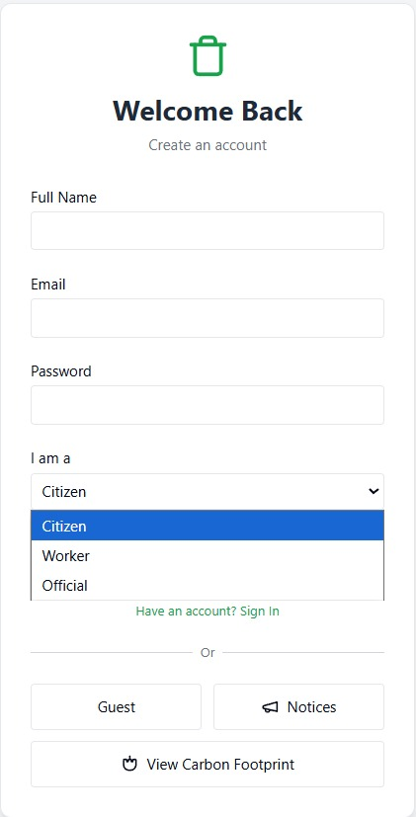
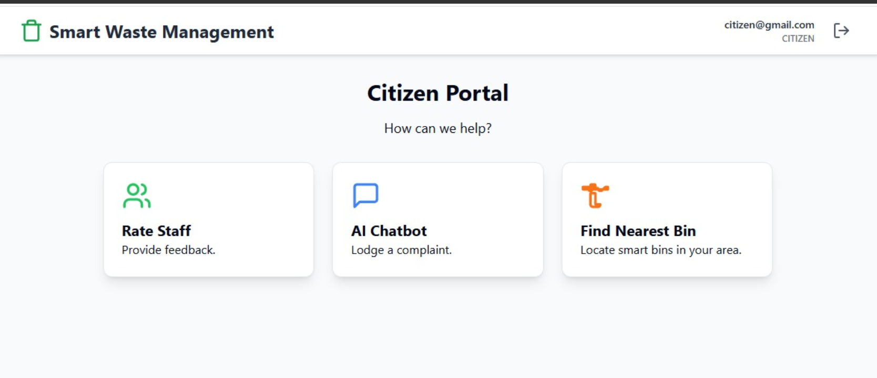AI Complaint Bot
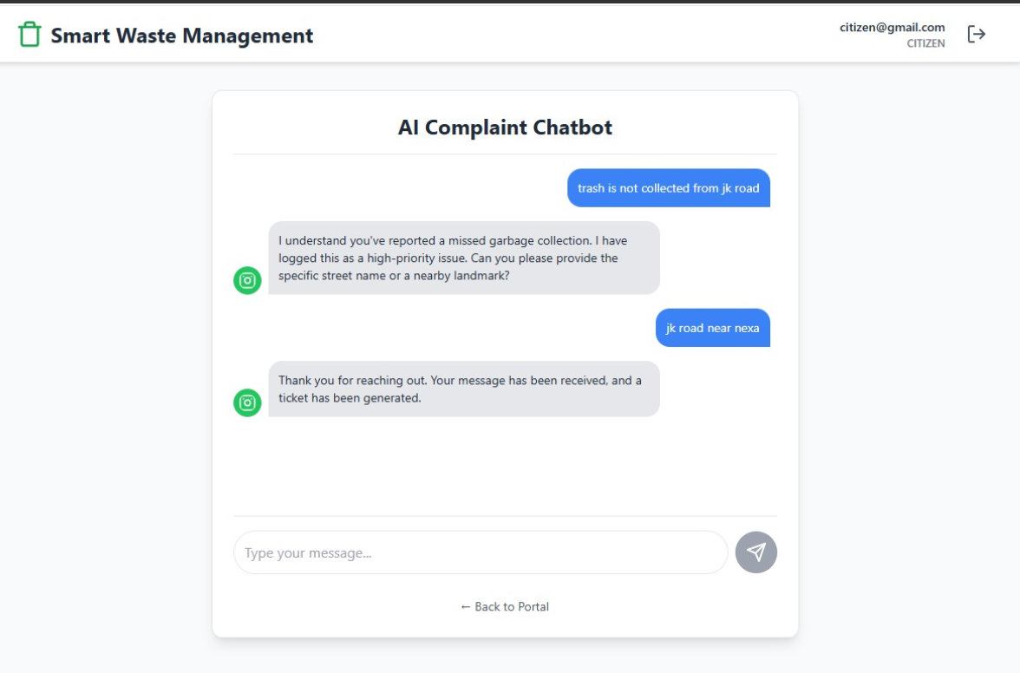

FEEDBACK PORTAL
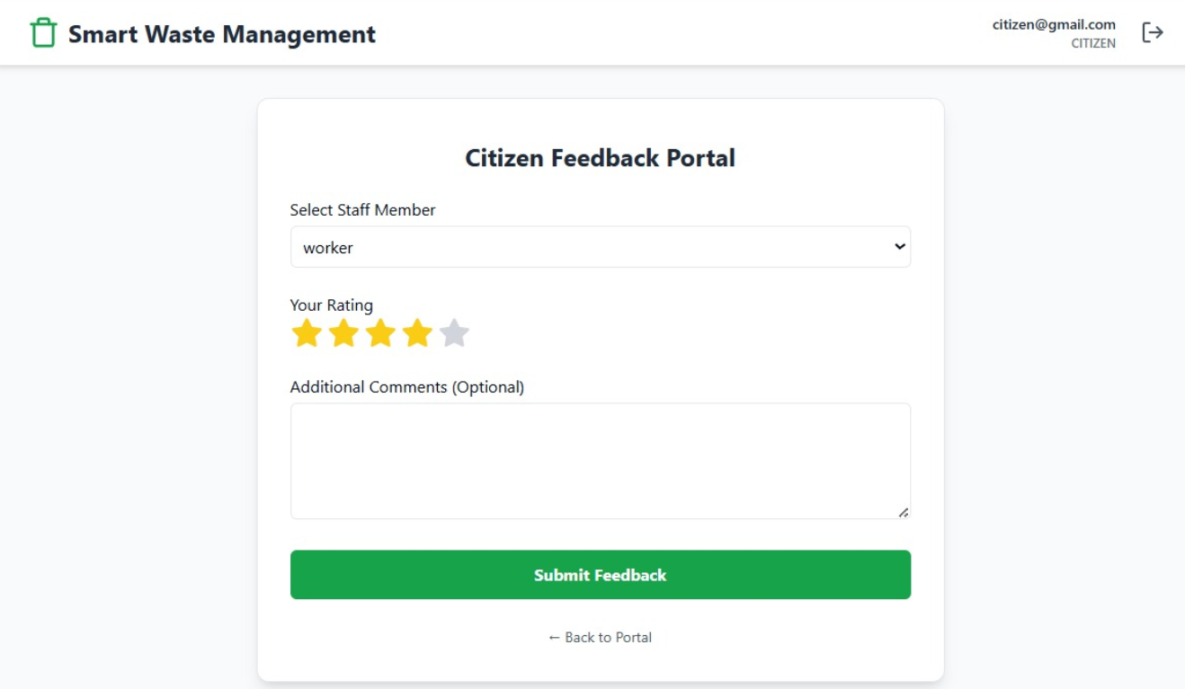
OFFICIAL DASHBOARD
